Week-2

GITHUB LINK: https://github.com/Zaina-Raheen/web-technology-and-mobile-application
Program-1
Inline:
<!DOCTYPE html>
<html>
<head>
<title>Voting Awareness - Inline</title>
</head>
<body style="background-color: #fdfefe; font-family: 'Arial', sans-serif; text-align: center;">
<h1 style="color: #2c3e50; border-bottom: 2px solid #e74c3c; display: inline-block; padding bottom: 5px;">
Online Voting Portal
</h1>
<p style="color: #34495e; font-size: 20px; font-style: italic; margin: 30px;"> "Your Vote is Your Voice. Use it wisely to shape the future."
</p>
<button style="background-color: #e74c3c; color: white; padding: 15px 30px; border: none; border-radius: 50px; cursor: pointer; font-weight: bold; box-shadow: 0 4px 6px rgba(0,0,0,0.1);">
REGISTER TO VOTE
</button>
</body>
</html>
Output:
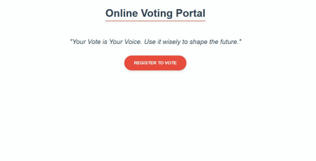Internal:
<!DOCTYPE html>
<html>
<head>
<title>Voting Awareness - Internal</title>
<style>
body {
background-color: #ecf0f1;
font-family: 'Segoe UI', Tahoma, Geneva, Verdana, sans-serif;
color: #2c3e50;
padding: 40px;
}
.awareness-card {
background-color: white;
border-left: 10px solid #2980b9;
padding: 20px;
border-radius: 8px;
box-shadow: 0 2px 10px rgba(0,0,0,0.1);
}
h1 {
color: #2980b9;
}
p {
line-height: 1.6;
font-size: 18px;
}
button {
background-color: #2980b9;
color: white;
border: none;
padding: 10px 25px;
font-size: 16px;
border-radius: 4px;
cursor: pointer;
}
button:hover {
background-color: #1a5276;
}
</style>
</head>
<body>
<div class="awareness-card">
<h1>Voter Awareness Dashboard</h1>
<p>This content is styled using Internal CSS. Our mission is to increase voter turnout through digital education and easy registration access.</p>
<button>Learn More</button>
</div>
</body>
</html>
Output:
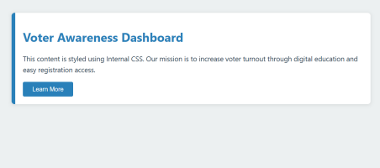
External:
<!DOCTYPE html>
<html>
<head>
<title>Voting Awareness - External</title>
<link rel="stylesheet" type="text/css" href="style.css">
</head>
<body>
<div class="main-container">
<h1>Digital Election Portal</h1>
<p>Empowering citizens through information. This page is formatted using an external stylesheet for a consistent look across the entire portal.</p>
<button class="login-btn">Portal Login</button>
</div>
</body>
</html>
Output:
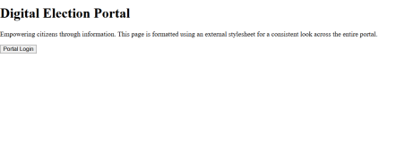Program 2
Inline & Internal:
<!DOCTYPE html>
<html>
<head>
<title>Vote Submitted</title>
<style>
/* Define the Animation */
@keyframes slideUp {
from {
opacity: 0;
transform: translateY(50px);
}
to {
opacity: 1;
transform: translateY(0);
}
}
body {
background: #27ae60; /* Green theme for success */
height: 100vh;
display: flex;
justify-content: center;
align-items: center;
font-family: Arial;
margin: 0;
}
.success-box {
background: white;
padding: 40px;
border-radius: 20px;
text-align: center;
box-shadow: 0 10px 30px rgba(0,0,0,0.2);
/* Apply the Animation */
animation: slideUp 1s ease-out;
}
h2 { color: #27ae60; }
.checkmark { font-size: 50px; color: #27ae60; }
</style>
</head>
<body>
<div class="success-box">
<div class="checkmark">✔</div>
<h2>Vote Recorded Successfully!</h2>
<p>Thank you for participating in the democratic process.</p> </div>
</body>
</html>
Output:
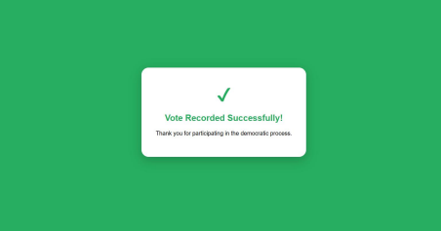
External:
body {
font-family: 'Verdana', sans-serif;
background-color: #1e272e; /* Dark theme */
color: #ffffff;
display: flex;
justify-content: center;
align-items: center;
height: 100vh;
margin: 0;
}
.main-container {
text-align: center;
background-color: #2f3542;
padding: 50px;
border-radius: 15px;
border: 1px solid #57606f; }
h1 {
color: #ffa502;
text-transform: uppercase; letter-spacing: 2px;
}
p {
font-size: 18px;
color: #ced4da;
max-width: 500px;
margin: 20px auto;
}
.login-btn {
background-color: #ffa502; color: #2f3542;
padding: 12px 30px;
border: none;
border-radius: 6px;
font-weight: bold;
cursor: pointer;
transition: 0.3s;
}
.login-btn:hover {
background-color: #eccc68; transform: scale(1.05); }

